### Creating an information pamphlet about Natural Disasters

How to be ready when disaster strikes

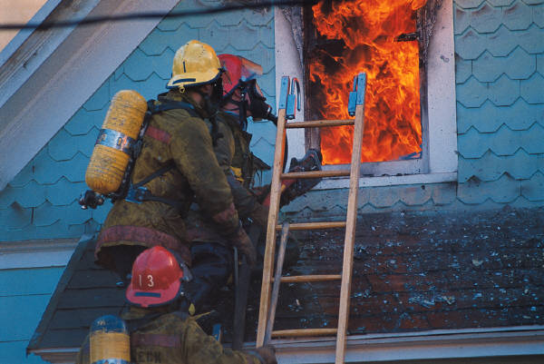

Natural Disaster Preparedness

🙞 🙜

90210 Huntley Street

Timbuctoo, ON

North Pole

Ms. Jazz

Check out city websites to see how they inform the public about natural disasters.

Ask Ms. Shipley or Ms. Jazz

Your textbooks are a great starting point for understanding natural disasters and climate

🙞 🙜

Natural disasters include:

Floods, Tornadoes, Hurricanes, Ice Storms, Forest Fires, Tsunamis, Earthquakes, Volcanoes, and more.

Different disasters require different readiness plans and emergency responses.

All pamphlets should include a list of steps to take in the event of a disaster.

#### What you should know about Natural Disasters

# FACTS

## Helpful resources

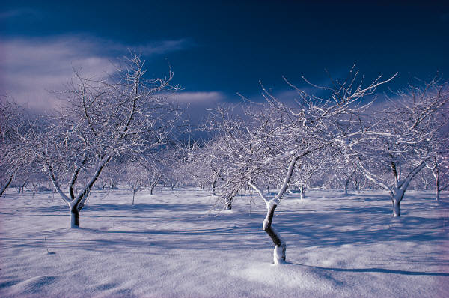

Title Page: should include the disaster, the region for which the pamphlet has been created, a date, and an image

Emergency preparedness checklist: this should include an emergency kit with a list of items as well as an outline of procedures in the case of a disaster.

Resources in the region: where to get help, emergency centers, and further information.

Facts about the Natural disaster: this section could include topics such as: what causes them, how often they occur in the region, how dangerous they can be, how the city or region is working to prevent fallout, or how the region is repairing from previous disasters.

For this assignment you will be required to create an informational pamphlet about a selected Natural Disaster in a selected region. Informational Pamphlets are to follow a similar template to this one; it must be double sided and folded in three for a combined total of 6 sections.

For this assignment you will work alone as your writing mechanics, language, creativity and independent research will be evaluated. No Exceptions. You must select a different natural disaster from that which you chose for your power point assignment.

Make sure your pamphlet is realistic; choose a real region such as Haiti, or New Orleans (areas that have been devastated in the past by Hurricanes).

Choose only natural disasters that are created as by climate, meteor strikes for example, are not an appropriate choice for this assignment.



# Assignment

## Contents